ADDENDUM 1

DATE: July 27, 2020
PROJECT: CIRCLE Pre-K Curriculum Materials
RFP NO: 744-R2017
OWNER: University of Texas Health Science Center at Houston
TO: Prospective Bidders

This Addendum forms part of and modifies Proposal Documents dated, July 14, 2020, with amendments and additions noted below. The questions below were received before the deadline and the responses are in blue (pages 1-2). A portion of Exhibit A from the original bid posting and four PDFs are also included with additional details (pages 3-11).

Please note, due to COVID-19, proposals should be submitted via email to Chevonne.E.Thornton@uth.tmc.edu and HUB Subcontracting Plans (HSP) should be submitted via email to Shaun.A.McGowan@uth.tmc.edu by their previously posted deadlines (Section 3.1 and Appendix One, Section 1.9.6).

- Question: On the Supplemental Materials (pages 10 & 11 of Exhibit A) - The first 3 items note if the item is to be printed double sided or single sided. Items 3-11 did not indicate this. Can you confirm if these items are to print double or single sided?
Answer: In the “Supplemental Materials” section, the only items that are double sided are the first two items (Alphabet Arc Mats and Letter Instruction Routine Cards). All the other Supplemental Materials are to be produced single sided.
- Question: Is there any printing on the inside covers of the manuals?
Answer: No.
- Question: Is it possible to see some images of previous manuals?
Answer: Yes; A sample Scope & Sequence (SS) guide as well as a sample Theme Guide are attached below Exhibit A at the end of this addendum (page 11).
- Question: Can we get some more exact specifications of the Supplemental Materials, or possibly some images?
Answer: The table below is pulled from Exhibit A; it includes an extended description - additional descriptive text and images (pages 3-10).
- Question: Is there an incumbent supplier or is this a new project?
Answer: This is a new project.
- Question: Are there any pricing records that we can view from the last RFP for this project?
Answer: No. Pricing cannot be discussed during the bidding process. Please provide your best value pricing for this project.
- Question: Is 100# Dull cover an acceptable thickness for the cover of the manuals?
Answer: Yes.

- Question: Will this project be a Print On Demand Program?
Answer: Yes.

- Question: Is it OK to use an alternate paper with the same specifications?
Answer: Yes.

- Question: The Bid spec list "Estimated Page Count". Does a page mean "a single sheet of paper printed 2 Sides"?
Answer: Yes; for example, Page Count 112 is 56 sheets of paper printed 2 sides.

- Question: Is the Acetate Cover - Front and Back "Clear"?
Answer: Yes.

- Question: Do the "Inside Pages" Bleed?
Answer: Yes.

- Question: Do both the Cover and Inside Pages print 2 Sides?
Answer: No. The covers will print 1 sided. There will be no content (no images and no text) on the back side of the sheet used for the front cover or of the sheet used for the back cover.

- Question: Do the Inside Pages print in Black only?
Answer: No; the inside pages will have Color print. Some pages will have solid bleed on the right edge that is referenced as a "Tab". This Tab identifies a section in the book.

- Question: Is a "Printed Proof" required?
Answer: No; Digital PDF Proof is required.

- Question: How many Shipping Locations do you estimate?
Answer: Estimated number of shipping locations for TSR is 60-100; Estimated number of shipping locations for SG is not yet defined.

- Question: On the RFP specs show 3 Cartons for shipping. Can it be 2 Cartons if everything fits?
Answer: Carton count will be determined by items and must ensure weight is not too heavy as there will be individual teachers of varying size and strength.

- Question: Will Print Files be sent as one release?
Answer: No - File releases will stagger; 60/70% will be released with English being first and then Spanish.

- Question: What is the estimated Ship Date on the project?
Answer: TSR "English" shipment is to deliver to locations by September 30th.

From Exhibit A
Supplemental Materials
Provide For | Name/Description | Quantity per Classroom | Proposed Size (small differences in dimensions are acceptable) | Specifications
TSR & SG | Alphabet Arc Mat  - 1 page, 2-sided  - Printed in color | 5 copies per English set  OR  5 copies per Spanish set | 11x17 inches | - Heavy paper like card stock  - Laminated or tear resistant/tear proof paper  - Shrink wrapped
Extended Description: Each teacher will receive a set of 5 Alphabet Arc mats to use with students who are working in a small group with the teacher. Each student will get one mat to use. Students will place the mat in front of themselves flat on the table. Teachers who receive materials in English will receive 5 English mats. Teachers who receive materials in Spanish will receive 5 Spanish mats. Images are provided below of the front and back of the English mat.

FRONT OF ENGLISH MAT
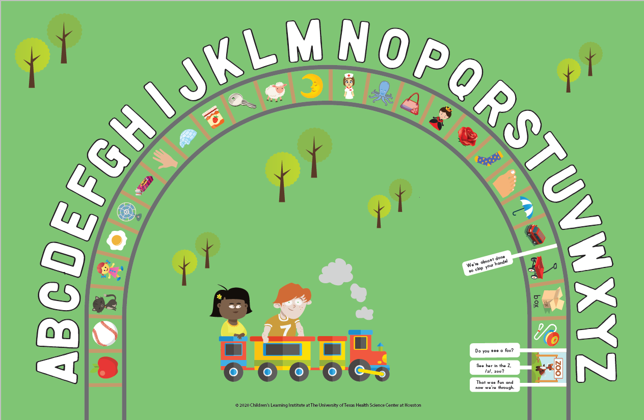

BACK OF ENGLISH MAT
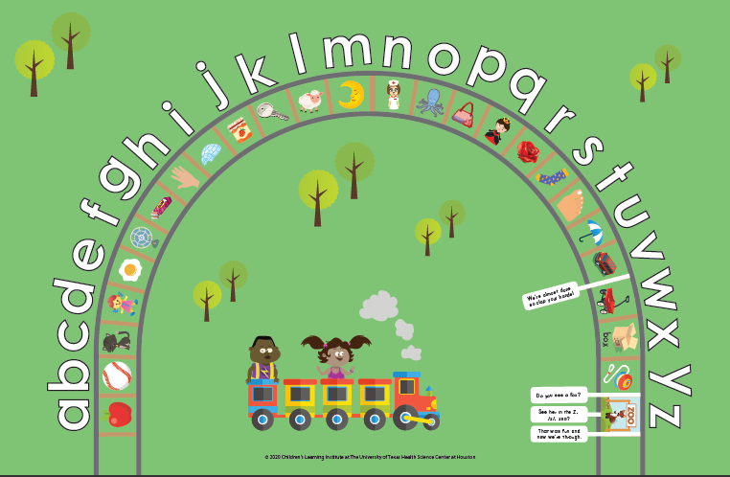
TSR & SG | Letter Instruction Routine Cards  - 26 cards per set English  - 27 cards per set Spanish  - Each card is 2-sided  - Printed in color | 1 English set  OR  1 Spanish set | 10x6 inches | - Heavy paper like card stock  - Laminated or tear resistant/tear proof paper  - Shrink wrapped
Extended Description: Each teacher will receive a set of shrink-wrapped cards. The front of the card will show a picture and the letter that goes with the picture. The back of the card will provide the teacher with instructions for how to teach that letter to students. Teachers will use these cards with students in whole and small group settings, and may also post them on the wall. Teachers who receive materials in English will receive a set of English cards. Teachers who receive materials in Spanish will receive a set of Spanish cards. Images are provided below of the front and back of one English card.

Front and back of one English card
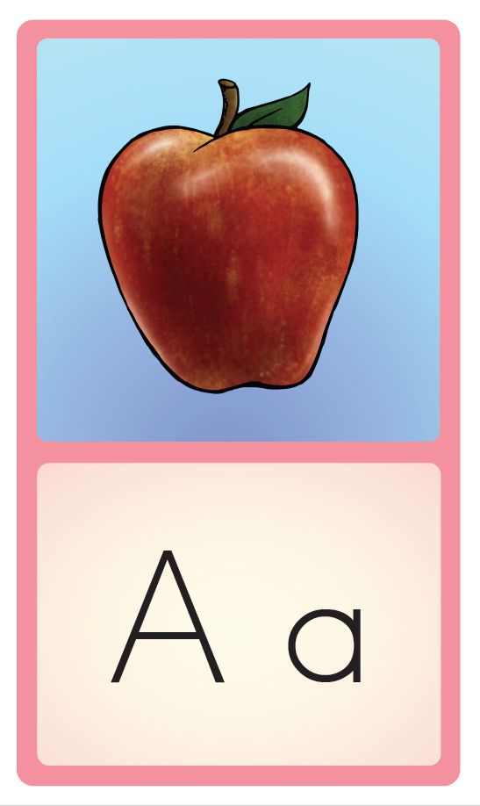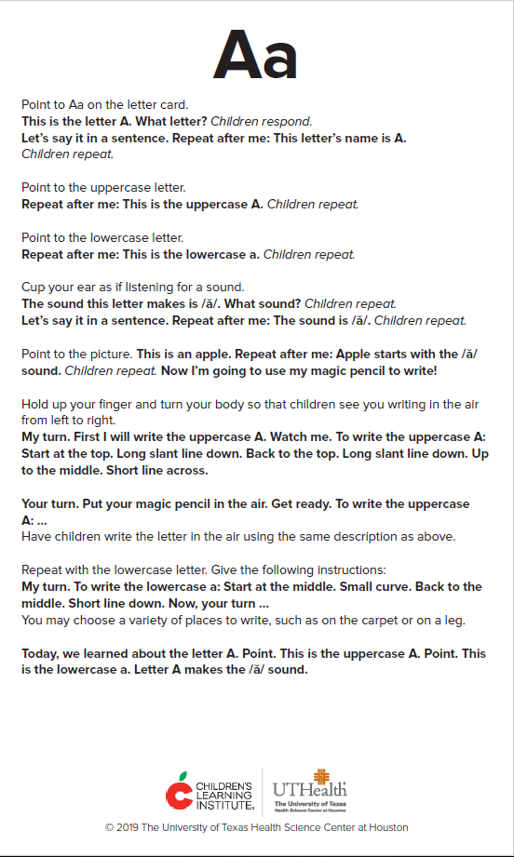

TSR & SG | Letter Cards  - 26 cards shrink wrapped English  - 27 cards shrink wrapped Spanish  - 1 sided  - Printed in color | 1 English set  OR  1 Spanish set | 6 x 3.5 inches | - Heavy paper like card stock  - Laminated or tear resistant/tear proof paper  - Shrink wrapped
Extended Description: Each teacher will receive one set of shrink-wrapped cards. These cards are one-sided and will only show the picture, and the letter that goes with it. These cards will not have anything on the back of the card. The image above showing the front of the English card shows how the front of these letter cards will look. Teachers will typically use these cards with students in small group settings, or will have students use them for independent letter review. Teachers who receive materials in English will receive a set of English cards. Teachers who receive materials in Spanish will receive a set of Spanish cards.
SG | Letter wall header cards  - 4 pages, all 1 sided  - Printed in color | 1 in English  OR  1 in Spanish | 10 x 24 inches | - Heavy paper like card stock  - Laminated or tear resistant/tear proof paper  - Shrink wrapped
Extended Description: These pages will include labels (one label for each letter of the alphabet, and up to 8 labels per page). Each label will be a strip that is 10 inches wide by 3 inches tall, and there will be a letter printed in upper and lower case on each label, along with the picture that goes with that label. Teachers will cut out these labels and they can tape the labels to the wall. Below each label teachers or children will tape pictures of things that begin with the sound for the letter, or they will tape words that start with the letter. There will be an English version of this resource, and a Spanish version. Below is a sample of what a single 10 x 3 Letter Wall Header card would look like.

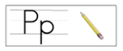
SG | Center Charts  - 8 pages, all 1 sided  - Printed in color | 1 English set  OR  1 Spanish set | 10 x 24 inches | - Heavy paper like card stock  - Laminated or tear resistant/tear proof paper  - Shrink wrapped
Extended Description: Center Charts will be hung on the wall by teachers to show a part of the room where students will work independently or in small groups on a particular type of activity. There will be 8 different center charts. There will be an English set of these charts, and a separate Spanish set. The picture below shows the concept for these charts. It shows how students in a class would be given a name card for themselves, and when students go to a center, they would put their name on the center chart.

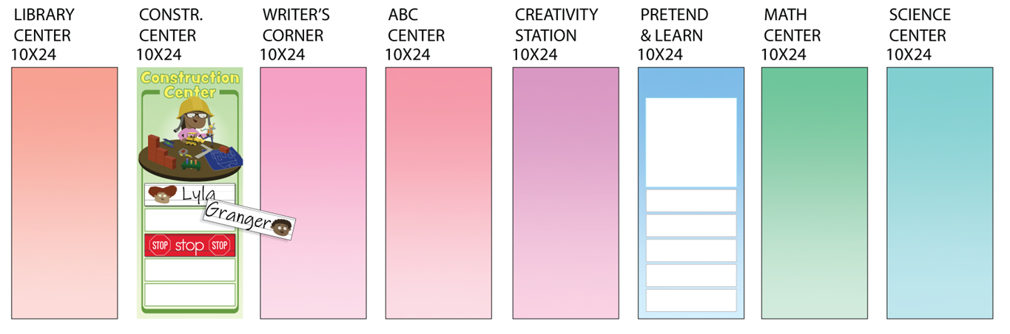
SG | Center Stop Sign Labels  - 1 page, 1 sided  - Printed in color | 1 in English  OR  1 in Spanish | 10 x 24 inches | - Heavy paper like card stock  - Laminated or tear resistant/tear proof paper
Extended Description: 8 Center Stop Sign labels will be printed on this one page. Each stop sign label will be 10 inches by 3 inches. Teachers will cut out these labels. Teachers can use these stop sign labels to indicate for each center how many students are allowed to work in the center. There will be an English page of these labels, and a separate Spanish page. The picture below shows the concept for how these stop sign labels will be used.

SG | Daily Schedule Chart  - 3 pages, all 1 sided  - Printed in color | 1 in English  OR  1 in Spanish | 24 x 36 inches | - Heavy paper like card stock  - Laminated or tear resistant/tear proof paper  - Shrink wrapped
Extended Description: The Daily Schedule Chart will be hung on the wall by teachers to show the order during which different parts of a PreK day will take place. The first page that will be printed for this item will include the chart itself. The next two pages will include strips that teachers can cut out to tape onto the Daily Schedule chart. Some examples of these strips are shown on the chart below. There will be an English set of pages for this chart, and a separate Spanish set. The picture below shows the concept for this chart.

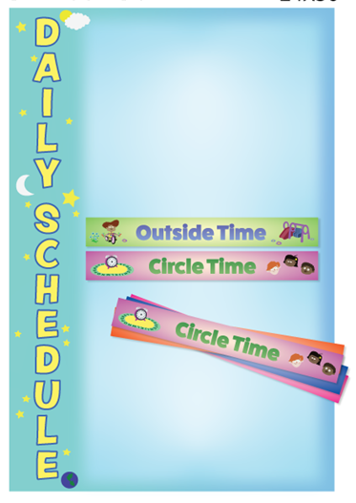

SG | Attendance Chart (classroom to neighborhood community)  - 1 page, 1 sided  - Printed in color | 1 in English  OR  1 in Spanish | 24 x 36 inches | - Heavy paper like card stock  - Laminated or tear resistant/tear proof paper
Extended Description: The Attendance Chart will be hung on the wall by teachers. Typically teachers give each child in the class a clip with their name and/or picture. When children arrive at school, all the clips for all the children are clipped along the sides on the bottom portion of the chart. When children arrive in the classroom, they “check in” by moving their clip to the top area of the chart. There will be an English version of this chart, and a separate Spanish version. The picture below shows the concept for this chart.

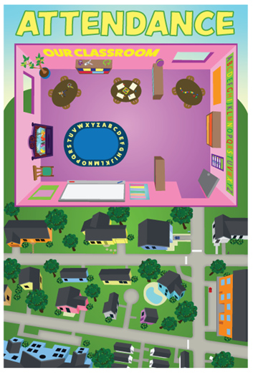

SG | Helper Chart  - 2 pages, both 1 sided  - Printed in color | 1 in English  OR  1 in Spanish | 24 x 36 inches | - Heavy paper like card stock  - Laminated or tear resistant/tear proof paper  - Shrink wrapped
Extended Description: The Helper Chart will be hung on the wall by teachers. Teachers will create their own labels for different classroom jobs, and teachers will create name tags to assign children to the jobs that are included on the chart. There will be an English version of this chart, and a separate Spanish version. The picture below shows the concept for this chart.

The Daily Schedule Chart will be hung on the wall by teachers. The first page that will be printed for this item will include the chart itself. The next page will include job cards that teachers can cut out to tape onto the Helper chart. Some examples of these job cards (I.e. snack, flag) are shown on the chart below. Teachers will create name tags to assign children to the jobs that are included on the chart. Some examples of these strips are shown on the chart below. There will be an English set of pages for this chart, and a separate Spanish set. The picture below shows the concept for this chart.

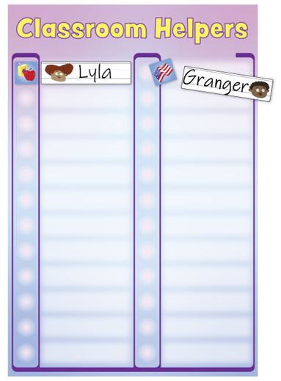

SG | Elkonin mats  - 1 page, 1 sided  - Printed in color | 5 copies per set (English and Spanish are the same) | 8.5 x 11 inches | - Heavy paper like card stock  - Laminated or tear resistant/tear proof paper  - Shrink wrapped
Extended Description: Each teacher will receive a set of 5 Elkonin Mats to use with students who are working in a small group with the teacher. Each student will get one mat to use. Students will place the mat in front of themselves flat on the table. The same Elkonin mat will be used in English and Spanish classrooms. We do not have a sample image of this mat.

SG | Math Story Mats  - 1 page, 1 sided  - Printed in color | 5 copies per set (English and Spanish are the same) | 8.5 x 11 inches | - Heavy paper like card stock  - Laminated or tear resistant/tear proof paper  - Shrink wrapped
Extended Description: Each teacher will receive a set of 5 Math Story Mats to use with students who are working in a small group with the teacher. Each student will get one mat to use. Students will place the mat in front of themselves flat on the table. The same mats will be used in English and Spanish classrooms. The image below represents the concept. Instead of a photograph, the actual mat will include an illustration.

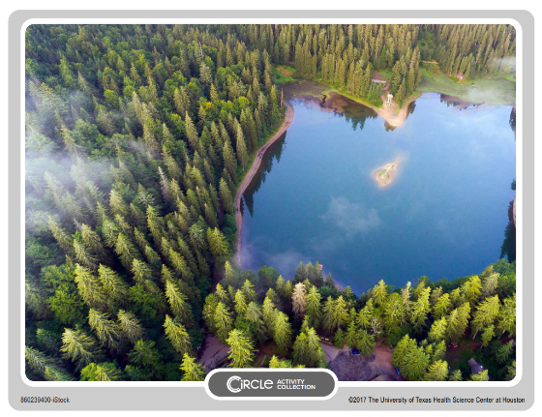

SG | Pointers  - 3 pages, all 1 sided  - Printed in color | 1 copy (same version used in English  and Spanish) | 8.5 x 11 inches approximately | - Heavy paper like card stock  - Laminated or tear resistant/tear proof paper
Extended Description: Each teacher will receive 3 pages of images. Teachers can cut out any of the images, and then attach the image to a popsicle stick or pencil to use as a pointer. The image below shows the concept for how the images will appear on a page. The same pointers will be used in English and Spanish classrooms.

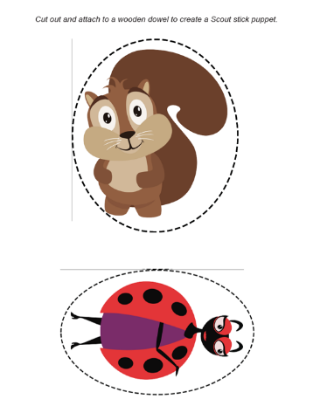

Samples – Question 3

